DISHES AND THEIR ALLERGEN CONTENT : BREAKTIME MENU.
(Note – Please state the name of the cereal(s) containing gluten** in that column AND/OR the name of the nut(s)* in that column)
DISHES | 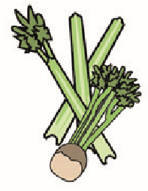 |  | 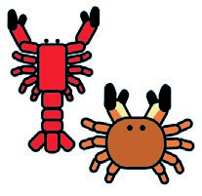 | 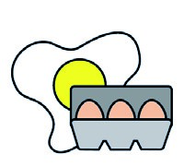 |  | 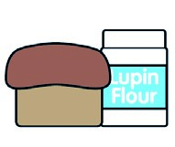 |  |  | 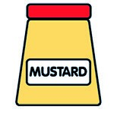 |  | 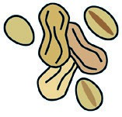 | 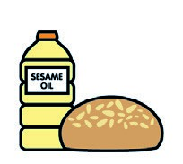 |  | 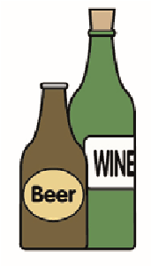
 | Celery | Cereals containing gluten** | Crustaceans | Eggs | Fish | Lupin | Milk | Molluscs | Mustard | Nuts* | Peanuts | Sesame seeds | Soya | Sulphur dioxide
Tuna Salad [example] | ✓ |  |  | ✓ | ✓ |  | ✓ |  | ✓
Sausage Roll |  | X |  |  |  |  | X
Cheese & Onion Bake |  | x |  |  |  |  | x |  | x |  |  |  | x
Pizza Bagel |  | x |  |  |  |  | x |  |  |  |  | x |  | x
Pepperoni & Cheese  Bagel | X | X |  | X |  |  | X |  | X |  |  | X | X | X
Garlic & Cheese Bagel |  | X |  |  |  |  | x |  |  |  |  | x |  | x
Cinnamon & Sugar Bagel |  | X |  |  |  |  | X |  |  |  |  | X
DISHES AND THEIR ALLERGEN CONTENT : BREAKTIME MENU.
(Note – Please state the name of the cereal(s) containing gluten** in that column AND/OR the name of the nut(s)* in that column)
DISHES
 | Celery | Cereals containing gluten** | Crustaceans | Eggs | Fish | Lupin | Milk | Molluscs | Mustard | Nuts* | Peanuts | Sesame seeds | Soya | Sulphur dioxide
Tuna Salad [example] | ✓ |  |  | ✓ | ✓ |  | ✓ |  | ✓
Bacon Cob |  | x |  |  |  |  |  |  |  |  |  | x
Sausage Cob |  | X |  |  |  |  |  |  |  |  |  | x |  | x
Vegan Sausage Cob |  | x |  |  |  |  |  |  |  |  |  | x
Spicy Bean Quesadilla |  | x |  |  |  |  | x
Mini Muffin |  | x |  | x |  |  | x |  |  |  |  |  | x
Buttered Crumpet |  | x |  |  |  |  | x
Buttered Fruit Teacake |  | x |  |  |  |  | x |  |  |  |  | x

Review Date: 02/04/2026 Reviewed by: J Empson

