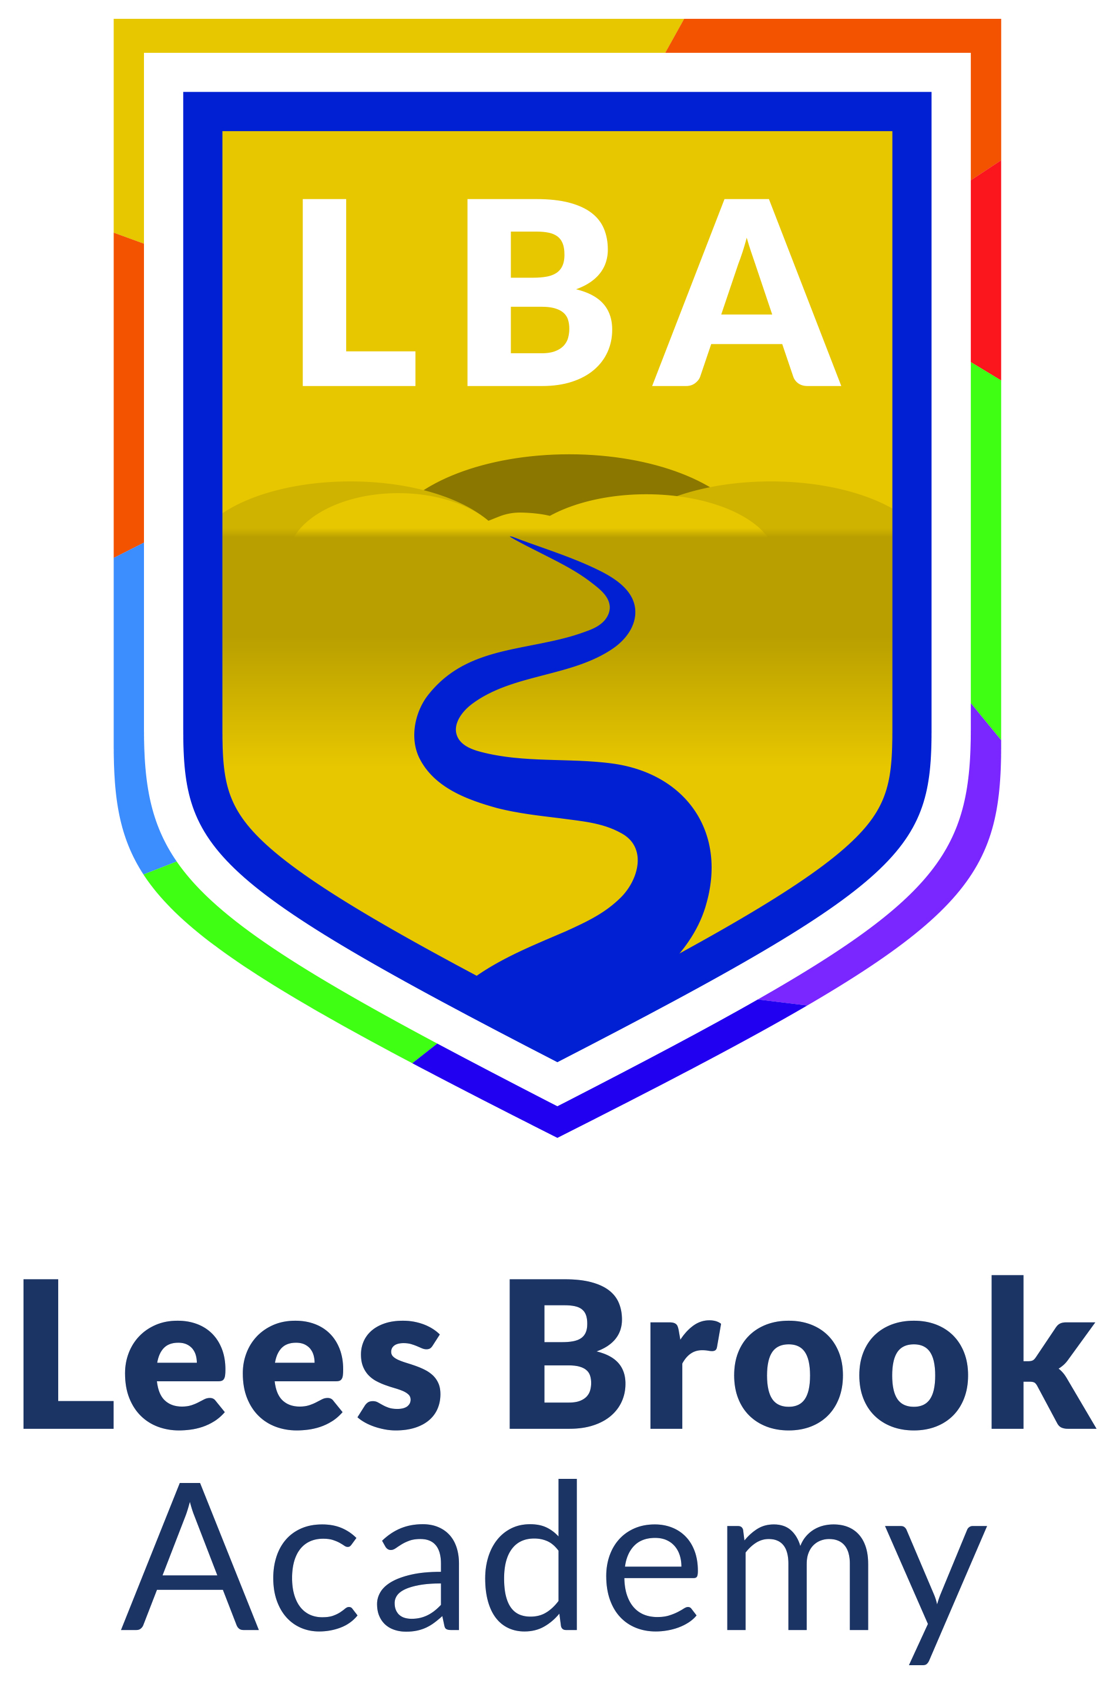

Assessment Dates 2025-2026
Students at Lees Brook Academy follow a Common Assessment Schedule in line with other schools in the Archway Learning Trust.
The assessment schedule for all year groups during this academic year is provided below.

Year | Aut1 | Aut2 | Spr1 | Spr2 | Sum1 | Sum2
7 | Reading Test |  | Subject Assessments
8 |  |  | Reading Test |  | Subject Assessments
9 |  |  | Subject Assessments  Reading Test
10 |  |  | Subject Assessments  Reading Test |  |  | GCSE Mock Exams
11 |  | GCSE Mock Exams |  | GCSE Mock Exams | Exams
12 |  | GCSE Mock Exams |  | GCSE Mock Exams | Exams
13 |  | GCSE Mock Exams |  | GCSE Mock Exams | Exams

