*Religious Studies* CURRICULUM

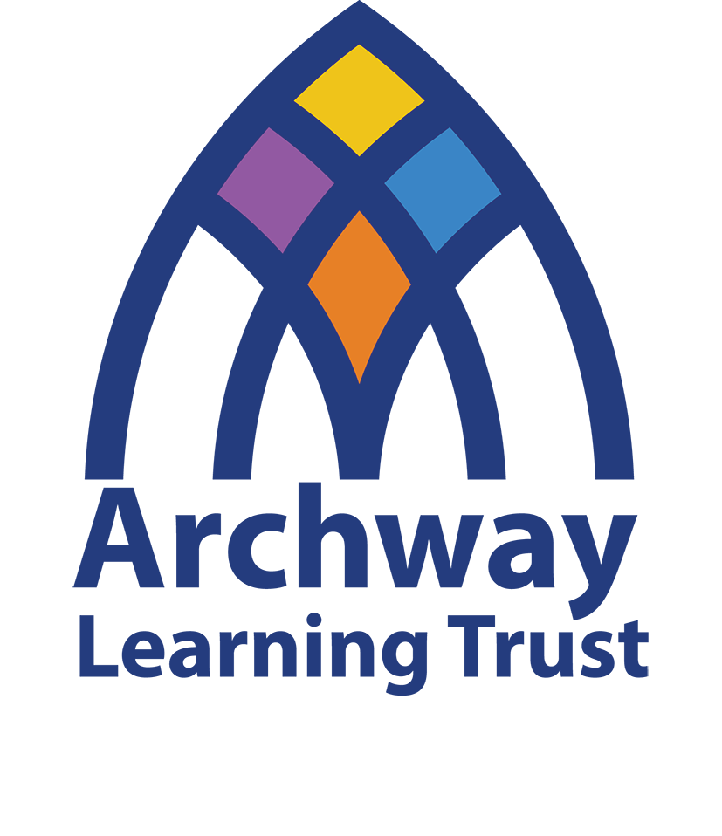

2024-25

Contents

Religious Studies Curriculum Intent 3

Domains of Knowledge 4

Substantive Knowledge Core Concepts 4

Disciplinary Knowledge 5

Personal Knowledge……………………………………………………………………………………………………………………………….…6

Key Stage End Points 6

Key Stage 3 6

Key Stage 4 8

# Religious Studies Curriculum Intent

At Archway Learning Trust, we desire that all learners come to understand and value the centrality of faith in our world. We aim to teach a Religious Studies curriculum that has powerful knowledge at its core, is academically challenging, culturally rich and relevant to all. We want learners to view Religious Studies as an academic subject with rigorous demands that align with the demands of other Humanities subjects.

It is our hope that through the study of RS, all learners develop a sense of identity and can evaluate their personal worldview whilst reflecting on the worldviews of others. They will develop an understanding of core concepts that fall under the three disciplines which have shaped the society that we live in today, namely: theology, philosophy and social sciences. These disciplines or ways of knowing will allow learners to explore what people believe in, how these beliefs are expressed and how, in turn, this influences the way in which people live. Our curriculum is ‘collectively enough’; it is not possible to cover all religious and non religious traditions and we do not intend to try. Content is selected so that students have a meaningful and deep understanding of some traditions. Thus, our course enables learners to become religiously literate whilst also building curiosity as they encounter traditions which have shaped the world we live in.

Each unit of work is underpinned by both a worldviews and hermeneutics approach in religious and secular sources of authority. We think it is important to use these texts as a foundation upon which to build, so that learners can start to unpick the role of interpretation in discerning religious beliefs. It is also important that we teach students to be critical interpreters who can reflect on their own position whilst appraising the scriptures presented. We want learners to gain a deeper understanding of how texts can be manipulated over time, but we also want them to recognise how these texts can still be relevant in society today. Through gaining this knowledge, we can promote tolerance and respect for those who are different to ourselves whilst also allowing students to understand how their own beliefs may shape their worldviews, morality and identity. Our RS curriculum prepares all for life in modern Britain, celebrating diversity and promoting inclusion whilst warning of the dangers of extremism and intolerance.

As well as this, our intent for all learners is that they can develop their skills of evaluation through encouraging them to formulate arguments in an academic and empathetic way. These discussions are key for our multi-cultural, ethnically diverse, pluralist society to function in a way that leads to harmony, peace and mutual respect for all.

# Domains of Knowledge

# Substantive Knowledge Core Concepts (What are students learning?)

The substantive knowledge has been organised according to the six core concepts below which are repeatedly encountered as part of a spiral curriculum. These have been influenced by the National Statement of Entitlement for RE and Barbara Wintersgill’s ‘Big Ideas’.

|  |  |
| --- | --- |
| Continuity, change and diversity | Religions and worldviews involve interconnected patterns of beliefs, practices and values. They are highly diverse and change in response to new situations and challenges. These can be the cause of debate, tension or conflict or result in new, creative developments. |
| Meaning and purpose | How worldviews may offer responses to fundamental questions raised by human experience. Such experiences can take place in both religious and non-religious contexts and may produce a heightened sense of awareness or identity, purpose and belonging. This may lead to the formation of a new beliefs/a worldview. |
| Wisdom and guidance | How beliefs and ideas are shaped and from sacred texts and art can impact upon lived expression of belief. This may involve exploring philosophy, ethics and spirituality from different worldviews. |
| Living well | How ideas and beliefs about what constitutes a ‘good life’ shape the way in which people choose to ‘live well’. Religious and non-religious communities often share an understanding of the characteristics and behaviours a good person will seek to achieve. There are points of agreement/disagreement over the interpretation and application of moral principles both across and within different religions/worldviews. |
| Authority and power | Religious and non-religious communities interact with wider society and cultures. These communities affect societies by shaping their traditions, laws, political systems, festivals, values and rituals. Some societies are influenced predominantly by one religion/worldview, others by several or many. |
| Grand Narratives | Religions/worldviews provide comprehensive accounts of how and why the world is as it is. They seek to answer the big questions about the universe and the nature of humanity. These narratives are usually based on approaches to life, texts or traditions, which are taken to be authoritative. |

# A black background with a black square Description automatically generated with medium confidenceDisciplinary Knowledge (How are students learning?)

This refers to the questions scholars ask of religious and non-religious worldviews and the methods, processes and tools they utilise to answer them. They are sometimes referred to as the ‘ways of knowing’ and/or the lenses through which the subject is studied.

|  |  |
| --- | --- |
| Theology | The study of the things that people believe. This includes exploring where beliefs come from, how they have changed over time, how different beliefs/concepts connect to each other within an overarching worldview and how different people understand and engage with their beliefs differently. A key method used by theologians is hermeneutics (textual interpretation). |
| Philosophy | Literally means ‘the love of wisdom’. This discipline is interested in what we know and how we know it. Philosophers ask questions about how people think or reason about the world around them and how we can know what is true or real. Key methods used by philosophers include thought experiments, debate, critical thinking and processes of reasoning. |
| Social Sciences | Encompassing a range of academic disciplines (history, sociology and geography) that are interested in the ways in which people live their lives. They ask questions about how people live and why they live in the ways they do and are particularly interested in how the context affects this. Key methods used by social scientists include surveys, interviews, ethnographic study and analysis of data. |

# Personal Knowledge (Who is learning? How does the content impact them?)

Each person is shaped by their own experiences and worldview and this impacts the way in which they engage in learning in the Religious Studies classroom. A key function of the Religious Studies curriculum is to enable students to critically analyse their own personal knowledge; that is, their presuppositions, beliefs, values and positionality. It is important to note that we should also acknowledge the personal knowledge of the curriculum designer and the teacher delivering the curriculum in the classroom.

# Key Stage End Points

The curriculum is a progression model. It is important that students know and are able to do what the curriculum intends.

## Key Stage 3

These have been informed by the Nottingham City Council and Nottinghamshire County Council Local Agreed Syllabus for RE 2021-2026.

1. Analyse and explain the core beliefs that form the foundation of religions and worldviews

**Learners will be able to:**

* 1. Understand key terms that are utilised when describing the nature of God
  2. Describe key beliefs associated with different religions and worldviews
  3. Understand how beliefs were formed, developed and shaped through history and how these have shaped cultures and worldviews examining questions of power and influence
  4. Explain the significance of these beliefs on a personal and communal level
  5. Reflect on your personal worldview and consider how these beliefs may shape how you live
  6. Evaluate beliefs by determining whether they are appropriate in the modern world
  7. Consider and evaluate: what is religion? Analyse the nature of religion using the main disciplines by which religion is studied

1. Understand the influence of religion and worldviews on individuals and communities

**Learners will be able to:**

a. Describe key practices and celebrations

b. Describe how and why practices and celebrations became traditions

c. Explain why religious practices and celebrations are important for believers

d. Understand how religions and worldviews shape the way that people behave

e. Understand how religions and worldviews have shaped the society we live in today

1. Appraise key sources of wisdom and authority, including scripture and/or sacred texts, to show how interpretation of text influences people

**Learners will be able to:**

* 1. Use quotes from religious texts to support beliefs, practices and arguments
  2. Explain how differing interpretations, author bias, context, subjectivity and audience can influence a person’s understanding of a text
  3. Discuss the relevance of texts for believers in a modern context
  4. Show an understanding of how texts can be misinterpreted and cause harm to societies

1. Construct well-informed and balanced arguments on matters concerned with religious beliefs/ worldviews, practices and values

**Learners will be able to:**

* 1. Explore some of the ultimate questions that are raised by human life in ways that are well informed
  2. Construct chains of reasoning to argue for and against in a debate
  3. Explain different scholarly opinions when tackling big questions
  4. Evaluate arguments considering areas of strength and weakness
  5. Develop your own opinion on matters, justifying this opinion in both written tasks and verbal debates
  6. Develop insightful evaluation and analysis of controversies about commitment to religions and worldviews, accounting for the impact of diversity within and between communities
  7. Maintain respect for all in the light of different perspectives from varied religions and worldviews

1. Demonstrate knowledge of how religious and secular sources of authority are used as a moral guide, comparing this to other ethical theories that may be applied in moral dilemmas

**Learners will be able to:**

1. Understand how people have different views on what is ethical and unethical
2. Explain an ethical theory, understanding that there are strengths and weaknesses
3. Apply ethical theories to current contexts and situations
4. Explain how communities use their sources of authority as a moral guide
   1. Give examples of laws and morality shown in sources of authority
   2. Analyse sources of morality, giving an opinion on whether the morality presented is reasonable or not
   3. Explore and express insight into significant moral and ethical questions posed by being human in ways that are well informed using reasoning which may draw on a range of examples

## Key Stage 4

1. Analyse and explain the core beliefs that form the foundation of religions and worldviews

**Learners will be able to:**

* 1. Explain how different religions and worldviews perceive the nature of God
  2. Explain key beliefs associated with religions and worldviews
  3. Examine the context in which beliefs were formed, developed and shaped through history
  4. Critically analyse the significance of these beliefs on a personal and communal level
  5. Evaluate and appraise beliefs by reflecting on their significance and determining whether they are appropriate in the modern world
  6. Account for varied interpretations of commitment to religion and worldviews and for responses to profound questions about the expression of identity, diversity, meaning and value
  7. Consider how religion/non religion is often presented in comparison with lived reality suggesting different explanations for this reflecting on questions of continuity, change, power and culture
  8. Select and apply appropriate disciplinary tools to evaluate explanations, recognising the impact of context

1. Understand the influence of religion and worldviews on individuals and communities

**Learners will be able to:**

a. Explain key practices and celebrations

b. Develop an understanding of the origins of religious practices and celebrations

c. Evaluate the significance of religious practices and celebrations

d. Eloquently express how religions and worldviews shape the way that people behave

e. Develop an understanding of how religions and worldviews have shaped laws throughout history and up to modern day

f. Develop coherent and well informed analysis of diversity in the forms of expression and ways of life found in different religions and worldviews

g. Use, independently, different disciplines and methods by which religions and worldviews are to analyse their influence on individuals and societies

1. Appraise key sources of wisdom and authority, including scripture and/or sacred texts, to show how interpretation of text influences people

**Learners will be able to:**

* 1. Apply quotes from religious texts to support, underpin or criticise beliefs, practices and arguments
  2. Appraise evidence used by people of faith, commenting on differing interpretations, author bias, context, subjectivity and audience
  3. Critically assess whether texts are still relevant for believers in a modern context
  4. Show an understanding of how texts can be manipulated to suit a certain agenda

1. Construct well-informed and balanced arguments on matters concerned with religious beliefs/ worldviews, practices and values

**Learners will be able to:**

* 1. Explain differing opinions to several topics of debate
  2. Apply key scholarship to debates
  3. Evaluate arguments from others giving both strengths and weaknesses, whilst ranking views to formulate justification
  4. Use a range of arguments and evidence to draw balanced conclusions
  5. Construct your own opinion and reasoned judgements, justifying this opinion in both written tasks and verbal debates

1. Demonstrate knowledge of how religious and secular sources of authority are used as a moral guide, comparing this to other ethical theories that may be applied in moral dilemmas

**Learners will be able to:**

* 1. Explain two or more ethical theories
  2. Evaluate ethical theories, developing both strengths and weaknesses
  3. Explain how and why communities use their sources of authority as a moral guide
  4. Give examples of laws and morality shown in sources of authority
  5. Critically analyse sources of morality and theories of application, to give an opinion on whether these approaches are reasonable or not
  6. Examine the relationship between institutional and individual worldviews while exploring ethical issues and suggest different explanations for this reflecting on questions of tradition