DISHES AND THEIR ALLERGEN CONTENT Week 1 Tuesday
(Note – Please state the name of the cereal(s) containing gluten** in that column AND/OR the name of the nut(s)* in that column)
DISHES | 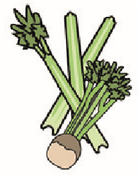 |  | 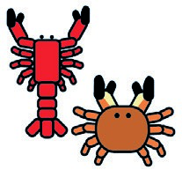 |  |  | 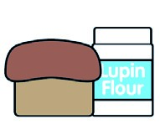 |  |  | 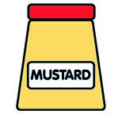 |  |  | 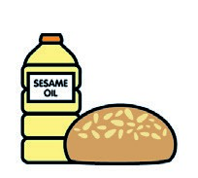 |  | 
 | Celery | Cereals containing gluten** | Crustaceans | Eggs | Fish | Lupin | Milk | Molluscs | Mustard | Nuts* | Peanuts | Sesame seeds | Soya | Sulphur dioxide
Tuna Salad [example] | ✓ |  |  | ✓ | ✓ |  | ✓ |  | ✓
Chicken Tikka Masala  Spiced Onions |  | Wheat |  |  |  |  | X |  | X
Cauliflower, Spiced Potato
Aloo Gobi
Naan Bread  Fiesta Rice / Mixed Salad |  | Wheat
Pasta 7- Veg Sauce |  | Wheat
Jacket Potato  Baked Beans / Cheese |  |  |  |  |  |  | X
Review date: 19/5/25 Reviewed by: D Hendry

