DISHES AND THEIR ALLERGEN CONTENT Week 1 Thursday
(Note – Please state the name of the cereal(s) containing gluten** in that column AND/OR the name of the nut(s)* in that column)
DISHES | 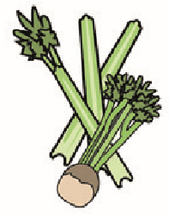 |  | 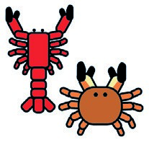 |  | 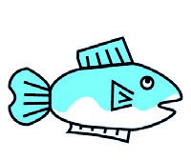 | 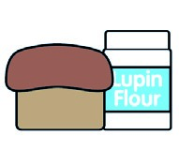 | 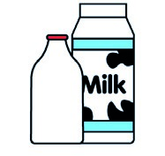 |  | 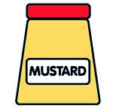 |  | 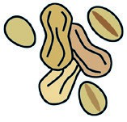 | 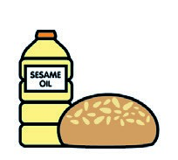 |  | 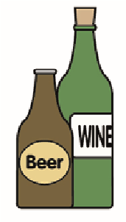
 | Celery | Cereals containing gluten** | Crustaceans | Eggs | Fish | Lupin | Milk | Molluscs | Mustard | Nuts* | Peanuts | Sesame seeds | Soya | Sulphur dioxide
Tuna Salad [example] | ✓ |  |  | ✓ | ✓ |  | ✓ |  | ✓
Salt & Pepper Chicken  Stir-fry Vegetable Noodles |  | Wheat  Wheat |  | X |  |  |  |  |  |  |  |  | X
Salt & Pepper Vegan Quorn  Dippers, Vegetable Noodles |  | Wheat
Cucumber & Cherry Tomato
Salad
Pasta 7- Veg Sauce |  | Wheat
Jacket Potato  Baked Beans / Cheese |  |  |  |  |  |  | X
Review date: 19/5/25 Reviewed by: D Hendry

