DISHES AND THEIR ALLERGEN CONTENT Week 3 Friday
(Note – Please state the name of the cereal(s) containing gluten** in that column AND/OR the name of the nut(s)* in that column)
DISHES | 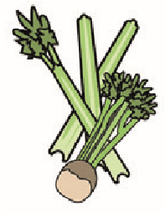 |  | 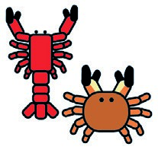 | 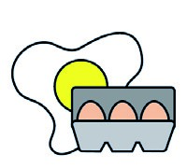 |  | 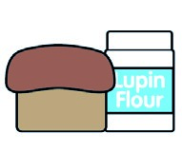 |  |  | 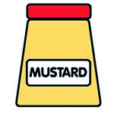 |  | 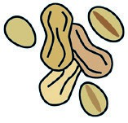 | 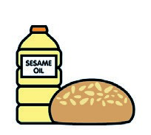 |  | 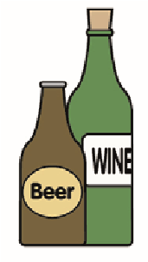
 | Celery | Cereals containing gluten** | Crustaceans | Eggs | Fish | Lupin | Milk | Molluscs | Mustard | Nuts* | Peanuts | Sesame seeds | Soya | Sulphur dioxide
Tuna Salad [example] | ✓ |  |  | ✓ | ✓ |  | ✓ |  | ✓
Pepperoni Pizza  Margarita Pizza | X | Wheat |  | X |  |  | X  X |  | X |  |  |  | X
Mac & Cheese |  | Wheat |  |  |  |  | X
Seasoned Wedges  Coleslaw |  |  |  | X
Pasta  7-Veg  Creamy Mushroom Sauce |  | Wheat |  |  |  |  | X
Review date: 19/5/25 Reviewed by: D Hendry

