DISHES AND THEIR ALLERGEN CONTENT Week 3 Thursday
(Note – Please state the name of the cereal(s) containing gluten** in that column AND/OR the name of the nut(s)* in that column)
DISHES | 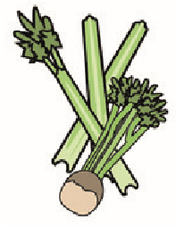 |  | 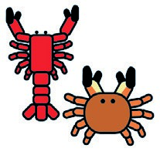 |  |  | 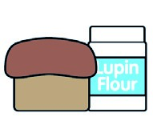 |  |  | 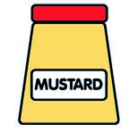 |  |  | 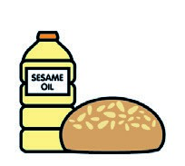 |  | 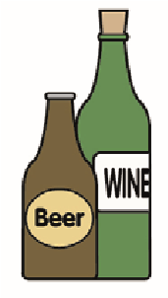
 | Celery | Cereals containing gluten** | Crustaceans | Eggs | Fish | Lupin | Milk | Molluscs | Mustard | Nuts* | Peanuts | Sesame seeds | Soya | Sulphur dioxide
Tuna Salad [example] | ✓ |  |  | ✓ | ✓ |  | ✓ |  | ✓
Mexican Chilli Beef Nachos  Salsa / Cheddar |  |  |  |  |  |  | X
Quorn Chilli Nachos  Salsa / Cheddar |  | Wheat |  |  |  |  | X
Fiesta Rice  Buttered Corn On The Cob |  |  |  |  |  |  | X
Pasta 7-Veg Sauce |  | Wheat
Jacket Potato  Baked Beans / Cheese |  |  |  |  |  |  | X
Review date: 19/5/25 Reviewed by: D Hendry

