DISHES AND THEIR ALLERGEN CONTENT Week 2 Wednesday
(Note – Please state the name of the cereal(s) containing gluten** in that column AND/OR the name of the nut(s)* in that column)
DISHES | 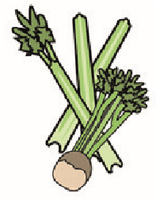 | 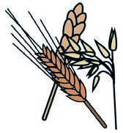 | 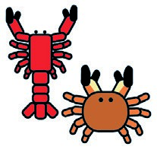 | 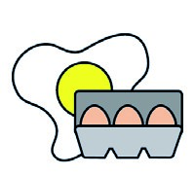 |  | 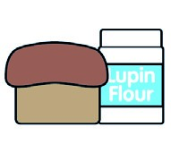 |  |  | 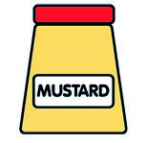 |  | 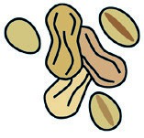 | 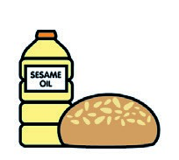 |  | 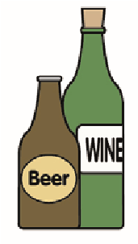
 | Celery | Cereals containing gluten** | Crustaceans | Eggs | Fish | Lupin | Milk | Molluscs | Mustard | Nuts* | Peanuts | Sesame seeds | Soya | Sulphur dioxide
Tuna Salad [example] | ✓ |  |  | ✓ | ✓ |  | ✓ |  | ✓
Penne Pasta  Beef Bolognese |  | Wheat
Quorn Bolognese Pasta Bake  Italian Bread |  | Wheat  Wheat |  | X  X
Cherry Tomato & Cucumber
Mixed Salad

Penne Pasta  7-Veg sauce  Spicy Sausage Tomato Sauce | X | Wheat  Wheat |  | X |  |  | X |  | X |  |  |  | X
Review date: 19/5/25 Reviewed by: D Hendry

