DISHES AND THEIR ALLERGEN CONTENT ..WEEK 1 (TUE)
(Note – Please state the name of the cereal(s) containing gluten** in that column AND/OR the name of the nut(s)* in that column)
DISHES | 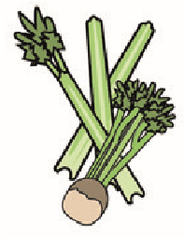 |  | 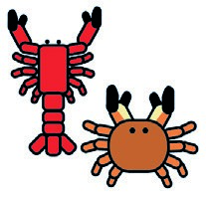 |  |  | 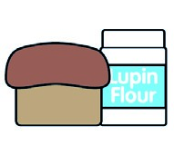 |  |  | 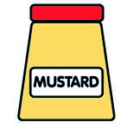 |  |  | 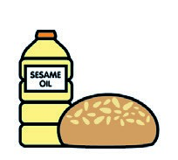 |  | 
 | Celery | Cereals containing gluten** | Crustaceans | Eggs | Fish | Lupin | Milk | Molluscs | Mustard | Nuts* | Peanuts | Sesame seeds | Soya | Sulphur dioxide
Tuna Salad [example] | ✓ |  |  | ✓ | ✓ |  | ✓ |  | ✓
BBQ Chicken  (GCM Thigh Strip In BBQ Glaze) |  |  |  |  |  |  |  |  |  |  |  |  | X
Tortilla Wrap  (787130) |  | (WHEAT) X
Fiesta Rice (183000)
Onions/Peppers/Carrots (John Palin)
Vegan Nuggets (799921)  BBQ Sauce (176330) |  | (WHEAT) X
Butter / 7-veg sauce
Veg Ratatouille mix/green beans/Palin
Pasta(105350)  7-Veg Sauce |  | (WHEAT) X
Jacket Potato (John Palin)
Beans(1050730)
Cheese (GCM) |  |  |  |  |  |  | X
Review date: 11/10/24 Reviewed by David Hendry

