DISHES AND THEIR ALLERGEN CONTENT ..WEEK 1 (MON)
(Note – Please state the name of the cereal(s) containing gluten** in that column AND/OR the name of the nut(s)* in that column)
DISHES | 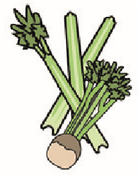 | 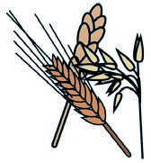 | 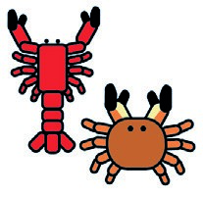 |  |  | 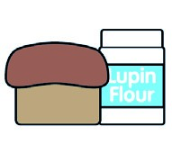 | 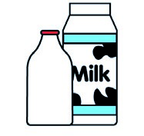 |  | 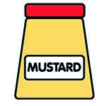 |  | 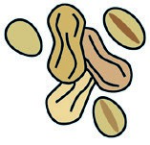 | 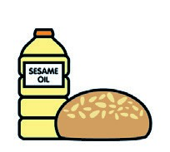 |  | 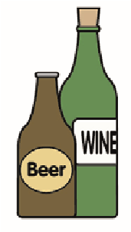
 | Celery | Cereals containing gluten** | Crustaceans | Eggs | Fish | Lupin | Milk | Molluscs | Mustard | Nuts* | Peanuts | Sesame seeds | Soya | Sulphur dioxide
Tuna Salad [example] | ✓ |  |  | ✓ | ✓ |  | ✓ |  | ✓
Giant Yorkshire Pudding  (799170) |  | (WHEAT) X |  | X |  |  | X
Mash Potato (JOHN PALIN)

¼ Cut Prepped Potatoes

Pork Sausage  (713410) |  | (WHEAT) X |  |  |  |  |  |  |  |  |  |  |  | X
G/F Gravy Mix
(215560)
Vegan Sausage  (799991) |  | (WHEAT) X
Roasted Root Vegetables

Swede Mash (John Palin, Prepped Veg)
Pasta (105350)  7-Veg Sauce |  | (WHEAT) X
Jacket Potato ( John Palin )

Beans (1050730)
Cheese (Great Central Meats) |  |  |  |  |  |  | X
Review date: 11/10/24 Reviewed by David Hendry

