DISHES AND THEIR ALLERGEN CONTENT ..WEEK 3 (WED)
(Note – Please state the name of the cereal(s) containing gluten** in that column AND/OR the name of the nut(s)* in that column)
DISHES | 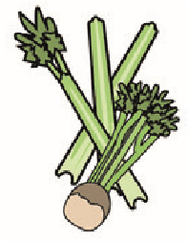 | 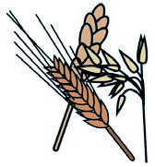 | 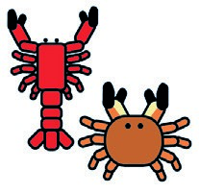 |  |  | 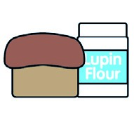 |  |  | 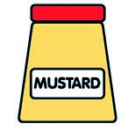 |  | 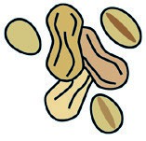 | 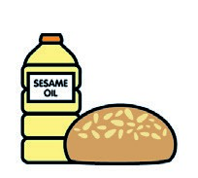 |  | 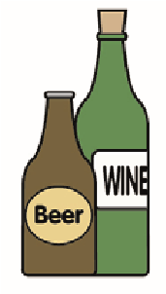
 | Celery | Cereals containing gluten** | Crustaceans | Eggs | Fish | Lupin | Milk | Molluscs | Mustard | Nuts* | Peanuts | Sesame seeds | Soya | Sulphur dioxide
Tuna Salad [example] | ✓ |  |  | ✓ | ✓ |  | ✓ |  | ✓
Pork Sausage (713140)  ¼ Cut Prepped Pots (Palin) |  | (WHEAT) X |  |  |  |  |  |  |  |  |  |  |  | X
Yorkshire Pudding (799150)  G/F Gravy Mix (215560) |  | (WHEAT) X |  | X |  |  | X
Vegan Sausage (799991)  Cauliflower/Baton Carrots (Palin) |  | (WHAT) X
Cheese (GCM)  Milk(154270)  Flour(140750)  Butter(352210) |  | (WHEAT) X |  |  |  |  | X  X
Pasta (105350)  7- Veg Sauce |  | (WHEAT) X
Jacket Potato (Palin)
Beans (1050730)
Review date: 11/10/24 Reviewed by: David Hendry

