DISHES AND THEIR ALLERGEN CONTENT ..WEEK 3 (TUE)
(Note – Please state the name of the cereal(s) containing gluten** in that column AND/OR the name of the nut(s)* in that column)
DISHES | 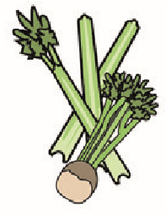 |  | 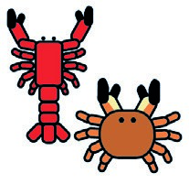 |  |  |  |  |  | 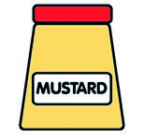 |  |  | 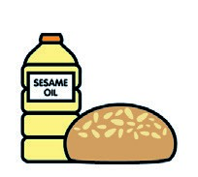 |  | 
 | Celery | Cereals containing gluten** | Crustaceans | Eggs | Fish | Lupin | Milk | Molluscs | Mustard | Nuts* | Peanuts | Sesame seeds | Soya | Sulphur dioxide
Tuna Salad [example] | ✓ |  |  | ✓ | ✓ |  | ✓ |  | ✓
BBQ Chicken  (GCM Thigh Strip in BBQ Glaze) |  |  |  |  |  |  |  |  |  |  |  |  | X
Tortilla Wrap (787130) |  | (WHEAT) X
Fiesta Rice (183000)
Onions/Peppers/Carrots (Palin)
Vegan Nuggets (799921)  BBQ Sauce (176330) |  | (WHEAT) X
Butter(352210)
Veg Ratatouille Mix/Green Beans(Palin
7- Veg Sauce)
Pasta (105350)  Jacket Potato (Palin) |  | (WHEAT X
Beans (1050730)  Cheese (GCM) |  |  |  |  |  |  | X
Review date: 11/10/24 Reviewed by: David Hendry

