DISHES AND THEIR ALLERGEN CONTENT ..WEEK 3 (THUR)
(Note – Please state the name of the cereal(s) containing gluten** in that column AND/OR the name of the nut(s)* in that column)
DISHES | 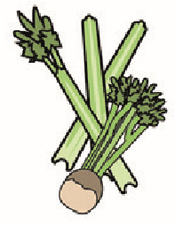 | 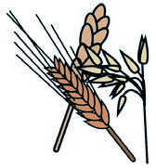 | 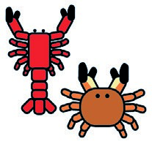 | 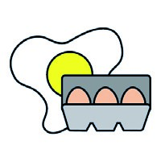 | 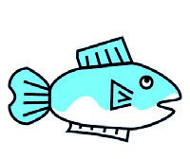 | 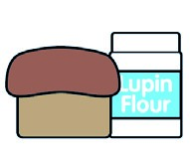 | 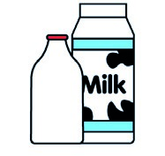 |  | 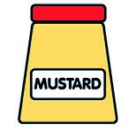 | 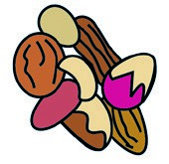 | 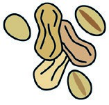 | 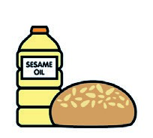 | 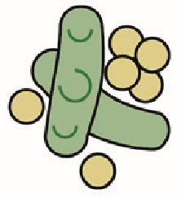 | 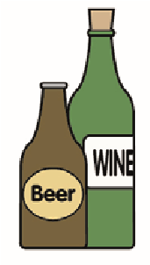
 | Celery | Cereals containing gluten** | Crustaceans | Eggs | Fish | Lupin | Milk | Molluscs | Mustard | Nuts* | Peanuts | Sesame seeds | Soya | Sulphur dioxide
Tuna Salad [example] | ✓ |  |  | ✓ | ✓ |  | ✓ |  | ✓
Southern Fried Chicken (GCM)  New Potatoes (PALIN) |  | (WHEAT) X
Spicy Sweetcorn Fritter (730410)
Butternut Squash (Palin)
White Cabbage/Leeks (Palin)
Butter (352210)
Pasta(105350)  Jacket Potato (Palin)  7- Veg Sauce |  | (Wheat) X
Cheese (GCM)  Beans (1050730) |  |  |  |  |  |  | X
Review date:11/10/24 Reviewed by: David Hendry

