DISHES AND THEIR ALLERGEN CONTENT ..WEEK 3 (MON)
(Note – Please state the name of the cereal(s) containing gluten** in that column AND/OR the name of the nut(s)* in that column)
DISHES | 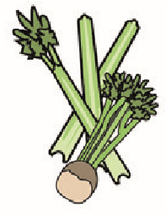 | 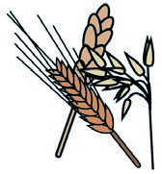 | 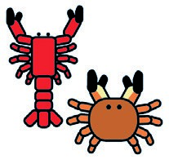 | 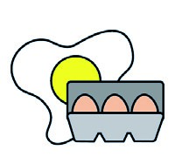 |  | 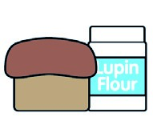 | 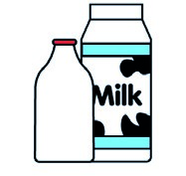 |  | 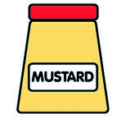 |  | 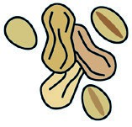 | 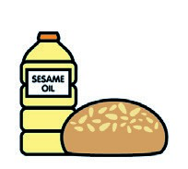 |  | 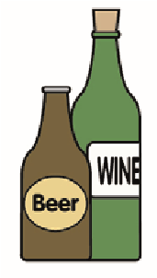
 | Celery | Cereals containing gluten** | Crustaceans | Eggs | Fish | Lupin | Milk | Molluscs | Mustard | Nuts* | Peanuts | Sesame seeds | Soya | Sulphur dioxide
Tuna Salad [example] | ✓ |  |  | ✓ | ✓ |  | ✓ |  | ✓
Beef Mince (GCM)  Pasta(105350) |  | (WHEAT) X
Garlic Bread (765300) |  | (WHEAT) X |  |  |  |  | X |  |  |  |  |  | X
Winter Veg Mix (Palin)
Root Vegetable (Palin)
Diced Swede (Palin)
Butter (352210)
Jacket Potato (Palin)
Beans (1050730)
Cheese (GCM)  7-Veg Sauce |  |  |  |  |  |  | X
Review date: 11/10/24 Reviewed by: David Hendry

