DISHES AND THEIR ALLERGEN CONTENT ..WEEK 3 (FRI)
(Note – Please state the name of the cereal(s) containing gluten** in that column AND/OR the name of the nut(s)* in that column)
DISHES | 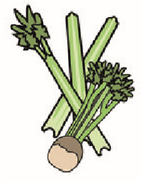 |  | 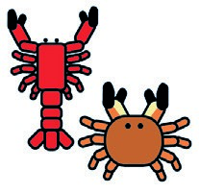 | 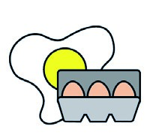 |  | 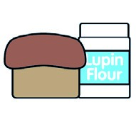 |  |  | 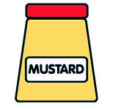 |  | 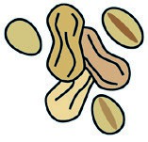 | 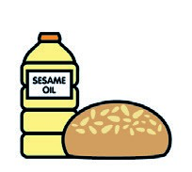 |  | 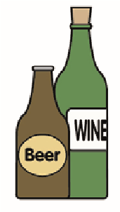
 | Celery | Cereals containing gluten** | Crustaceans | Eggs | Fish | Lupin | Milk | Molluscs | Mustard | Nuts* | Peanuts | Sesame seeds | Soya | Sulphur dioxide
Tuna Salad [example] | ✓ |  |  | ✓ | ✓ |  | ✓ |  | ✓
Breaded Fishcake (737600)  Seasoned Wedges (751231) |  | (WHEAT) X |  |  | X |  | X |  | X
Beans (1050730)  Quorn Fishless Fingers (798991) |  | (WHEAT) X
Carrots (Palin)
Broccoli (Palin)
Pasta (105350)  7-Veg Sauce |  | (WHEAT) X
Jacket Potato (Palin)  Cheese (GCM) |  |  |  |  |  |  | X
Review date:11/10/24 Reviewed by: David Hendry

