DISHES AND THEIR ALLERGEN CONTENT ..WEEK 2 (WED)
(Note – Please state the name of the cereal(s) containing gluten** in that column AND/OR the name of the nut(s)* in that column)
DISHES | 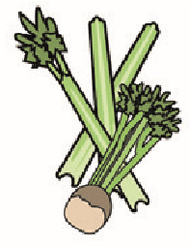 | 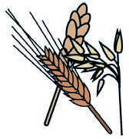 | 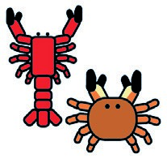 |  |  | 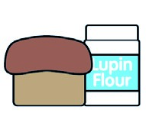 | 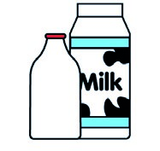 |  | 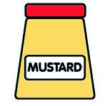 |  | 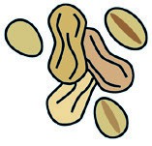 | 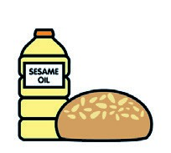 |  | 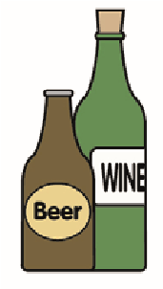
 | Celery | Cereals containing gluten** | Crustaceans | Eggs | Fish | Lupin | Milk | Molluscs | Mustard | Nuts* | Peanuts | Sesame seeds | Soya | Sulphur dioxide
Tuna Salad [example] | ✓ |  |  | ✓ | ✓ |  | ✓ |  | ✓
Chicken Thigh (GCM)
¼ Cut Prepped Potatoes (Palin)
Garlic (1065260)
Thyme (189581)
Quorn Vegan Fillet (799981) |  | (WHEAT) X
Yorkshire Pudding (799150)  G/F Gravy Mix (215560) |  | (WHEAT) X |  | X |  |  | X
Broccoli / Cauliflower (Palin)  Flour(140750)  Milk(154270)  Butter(352210) |  | (WHEAT) X |  |  |  |  | X
Pasta(105350)  Jacket Potato (Palin) |  | (WHEAT) X
Cheese (GCM)  Beans (1050730) |  |  |  |  |  |  | X
Review date: 11/10/24 Reviewed by David Hendry

