DISHES AND THEIR ALLERGEN CONTENT ..WEEK 2 (THUR)
(Note – Please state the name of the cereal(s) containing gluten** in that column AND/OR the name of the nut(s)* in that column)
DISHES | 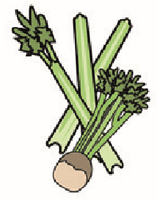 | 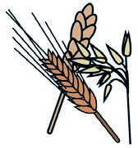 | 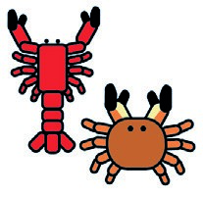 | 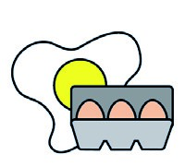 |  | 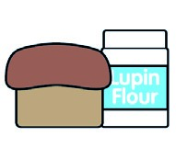 | 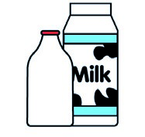 |  | 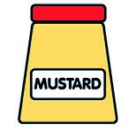 | 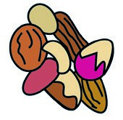 | 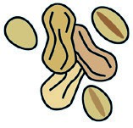 | 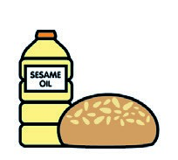 |  | 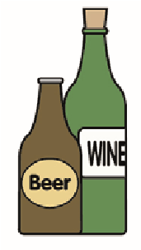
 | Celery | Cereals containing gluten** | Crustaceans | Eggs | Fish | Lupin | Milk | Molluscs | Mustard | Nuts* | Peanuts | Sesame seeds | Soya | Sulphur dioxide
Tuna Salad [example] | ✓ |  |  | ✓ | ✓ |  | ✓ |  | ✓
Diced Chorizo (349181)  Garlic Bread (765300) |  | (WHEAT) X |  |  |  |  | X  X |  |  |  |  |  | X
Pasta(105350)  Cheese (GCM)  7- Veg Sauce |  | (WHEAT) X |  |  |  |  | X
Butternut Squash (Palin)
Carrots (Palin)
Jacket Potato (Palin)
Beans (1050730)
Review date: 11/10/24 Reviewed by: David Hendry

