DISHES AND THEIR ALLERGEN CONTENT ..WEEK 2 (MON)
(Note – Please state the name of the cereal(s) containing gluten** in that column AND/OR the name of the nut(s)* in that column)
DISHES | 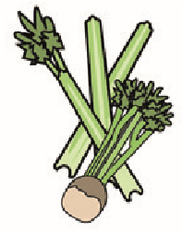 | 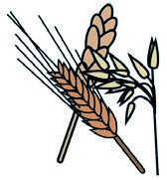 | 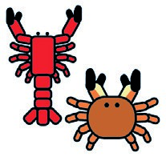 | 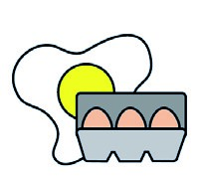 |  | 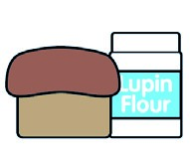 | 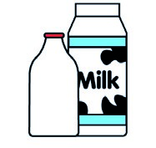 |  | 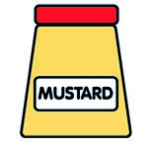 |  | 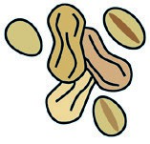 | 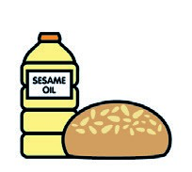 |  | 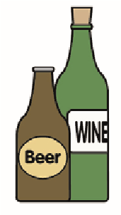
 | Celery | Cereals containing gluten** | Crustaceans | Eggs | Fish | Lupin | Milk | Molluscs | Mustard | Nuts* | Peanuts | Sesame seeds | Soya | Sulphur dioxide
Tuna Salad [example] | ✓ |  |  | ✓ | ✓ |  | ✓ |  | ✓
Baguette (817650)  Onions (Palin) |  | (WHEAT) X |  | X |  |  |  |  |  |  |  | X
Jumbo Pork Sausage (GCM)  Crispy Diced Potatoes (752811) |  | (WHEAT) X  (WHEAT) X |  |  |  |  |  |  |  |  |  |  |  | X
Vegan Sausage (799991)  Cob (817190) |  | (WHEAT) X  (WHEAT) X |  |  |  |  |  |  |  |  |  | X
Root Vegetable (Palin)
Ratatouille Mix (Palin)
&- Veg Sauce
Pasta(105350)  Jacket Potato (Palin) |  | (WHEAT) X
Beans (1050730)  Cheese (GCM) |  |  |  |  |  |  | X
Review date: 11/10/24 Reviewed by: David Hendry

