DISHES AND THEIR ALLERGEN CONTENT ..WEEK 2 (FRI)
(Note – Please state the name of the cereal(s) containing gluten** in that column AND/OR the name of the nut(s)* in that column)
DISHES | 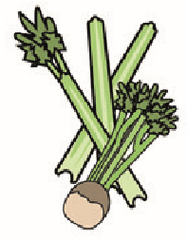 | 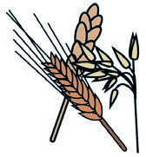 | 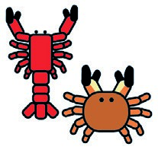 | 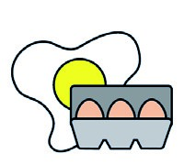 |  | 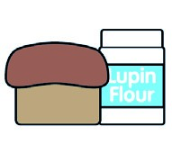 | 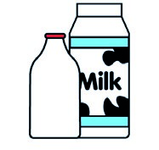 |  | 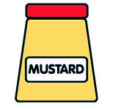 |  | 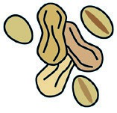 | 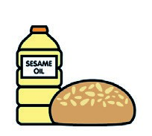 |  | 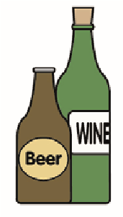
 | Celery | Cereals containing gluten** | Crustaceans | Eggs | Fish | Lupin | Milk | Molluscs | Mustard | Nuts* | Peanuts | Sesame seeds | Soya | Sulphur dioxide
Tuna Salad [example] | ✓ |  |  | ✓ | ✓ |  | ✓ |  | ✓
LOADED FRYDAY
BBQ Sauce (176330)
Pork Collar (GCM)  Rainbow Coleslaw (Palin) |  |  |  |  |  |  |  |  |  |  |  |  |  | X
Seasoned Wedges (751231)  Crispy Onions (154780) |  | (WHEAT) X
Cajun Seasoning (189631)  Pasta(105350)  7-Veg Sauce |  | (WHEAT) X
Cheese (GCM)  Jacket Potato (Palin) |  |  |  |  |  |  | X
Beans (1050730)  Flour(140750)  Butter (352210)  Milk(154270) |  | (WHEAT) X |  |  |  |  | X
Garden Peas(760560)
Parsnips (Palin)

Review date: 11/10/24 Reviewed by: David Hendry

