DISHES AND THEIR ALLERGEN CONTENT ..WEEK 1 (WED)
(Note – Please state the name of the cereal(s) containing gluten** in that column AND/OR the name of the nut(s)* in that column)
DISHES | 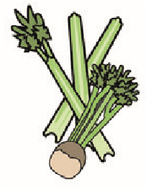 | 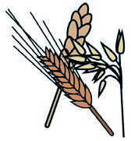 | 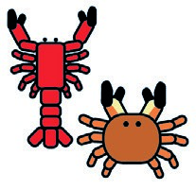 |  |  | 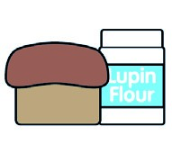 | 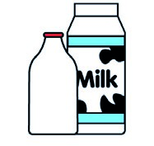 |  | 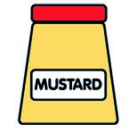 |  | 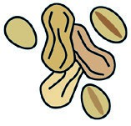 | 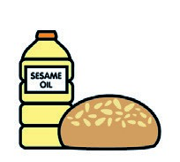 |  | 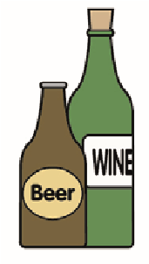
 | Celery | Cereals containing gluten** | Crustaceans | Eggs | Fish | Lupin | Milk | Molluscs | Mustard | Nuts* | Peanuts | Sesame seeds | Soya | Sulphur dioxide
Tuna Salad [example] | ✓ |  |  | ✓ | ✓ |  | ✓ |  | ✓
Honey (272010)
Gammon Horseshoe (GCM)
¼ Cut Prepped Potatoes (PALIN)  Yorkshire Pudding (799150) |  | Wheat X |  | X |  |  | X
G/F Gravy Mix (215560)  Quorn Vegan Fillet (799981) |  | Wheat X
Baton Carrots/ Cauliflower (Palin)  Flour (140750)  Butter (352210)  Milk (154270) |  | Wheat X |  |  |  |  | X  X
Pasta (105350)  Jacket Potato (Palin) |  | Wheat X
Cheese (GCM)  Beans (1050730) |  |  |  |  |  |  | X
7-Veg Sauce
Review date: 11/10/24 Reviewed by: David Hendry

