DISHES AND THEIR ALLERGEN CONTENT ..WEEK 1 (FRI)
(Note – Please state the name of the cereal(s) containing gluten** in that column AND/OR the name of the nut(s)* in that column)
DISHES | 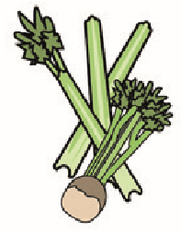 | 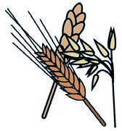 | 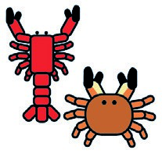 | 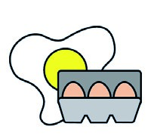 |  | 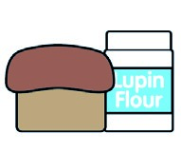 | 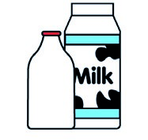 |  | 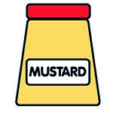 |  | 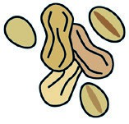 | 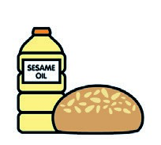 |  | 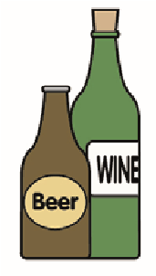
 | Celery | Cereals containing gluten** | Crustaceans | Eggs | Fish | Lupin | Milk | Molluscs | Mustard | Nuts* | Peanuts | Sesame seeds | Soya | Sulphur dioxide
Tuna Salad [example] | ✓ |  |  | ✓ | ✓ |  | ✓ |  | ✓
Battered Cod Fillet (723840)  Seasoned Wedges (151230) |  | (WHEAT) X |  |  | X
Beans (1050730)  Pasta (105350) |  | (WHEAT) X
Cheese (GCM)  Milk (154270)  Butter (325510)  Flour (140750) |  | (WHEAT) X |  |  |  |  | X  X
Diced Carrots ( Palin)
Broccoli (Palin)
Pasta  Jacket Potato (Palin) |  | (WHEAT) X
7-Veg Sauce
Review date: 11/10/24 Reviewed by: David Hendry

